

|  |  |  |  |  |  |
| --- | --- | --- | --- | --- | --- |
| Programme | : | **M.Tech. (Integrated) Software Engineering** | Semester | : | **Fall 20-21** |
| Course | : | **Advanced Database Management Systems** | Code | : | **SWE2014** |
| Faculty | : | **Dr.Bhuvaneswari A** | Slot | : | **L27 + L28** |
| Date | : | **21-07-2020** | Marks | : | **10 Points** |

**NAME: K. NAVEEN KUMAR**

**REG NO: 17MIS1056**

**Exercise 2: SQL – Advanced Filtering and Sorting**

**In Live SQL Oracle : Use HR Schema with Employee & Department Table**

1. Write a query in SQL to display the first and last name, and department number for all employees whose last name is “McEwen”.

ANS:

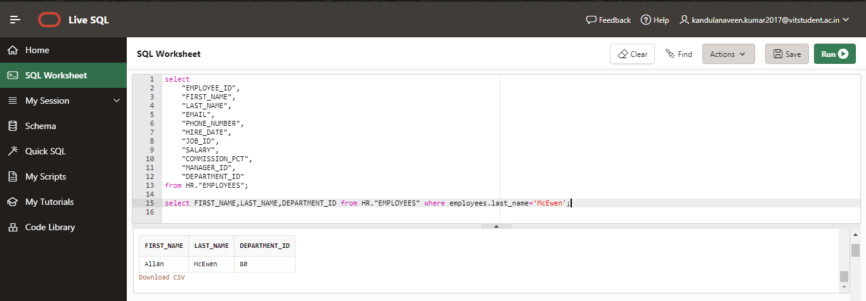

1. Write a query in SQL to display the first and last_name, department number and salary for those employees who earn more than 8000.

Ans:

select first_name,last_name,DEPARTMENT_ID,salary

from HR."EMPLOYEES"

where salary>8000

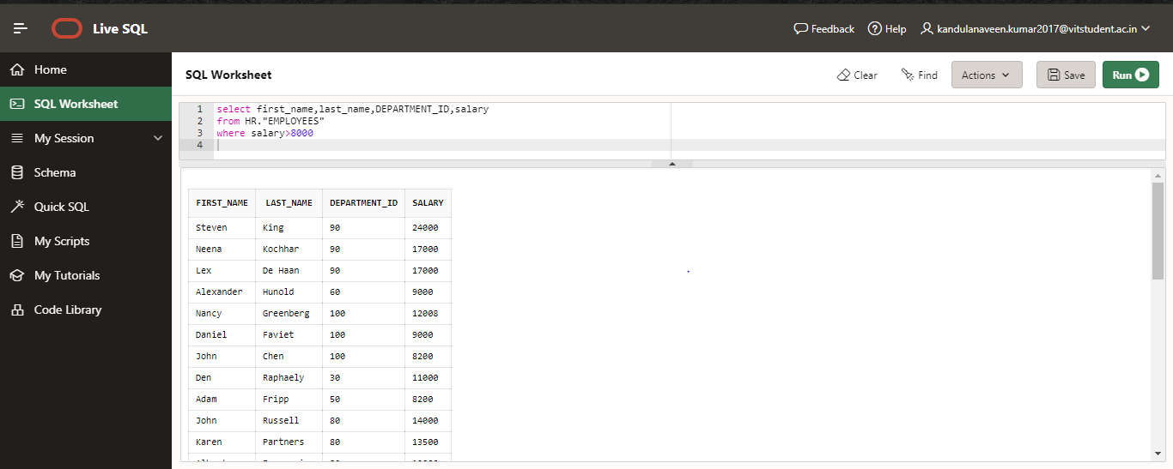

1. Write a query in SQL to display the full name (first and last), hire date, salary, and department number for those employees whose first name does not containing the letter M and make the result set in ascending order by department number.

ANS:

select first_name||''||last_name as fullname,hire_date,salary,DEPARTMENT_ID

from HR."EMPLOYEES" where first_name not like '%M%'

order by employees.DEPARTMENT_ID

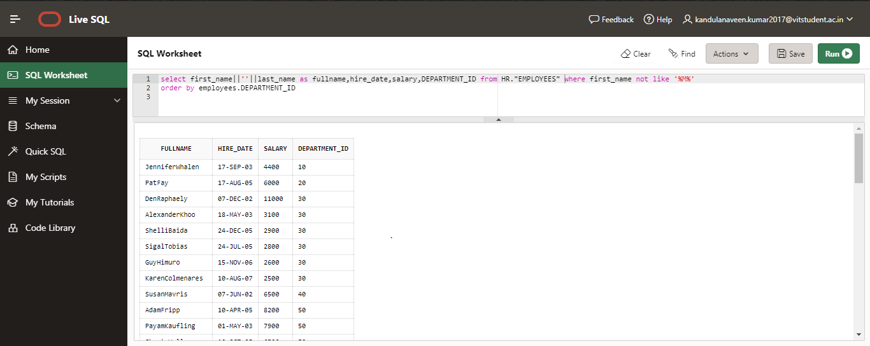

1. Write a query in SQL to display all the information of employees whose salary is in the range of 8000 and 12000 and commission is not null or department number is except the number 40, 120 and 70 and they have been hired before June 5th, 1987

ANS:

select * from HR."EMPLOYEES"

where employees.salary>'8000' and employees.salary<'12000'

and COMMISSION_PCT is not null or DEPARTMENT_ID in (40,120,70)

and HIRE_DATE<'05-JUN-87'

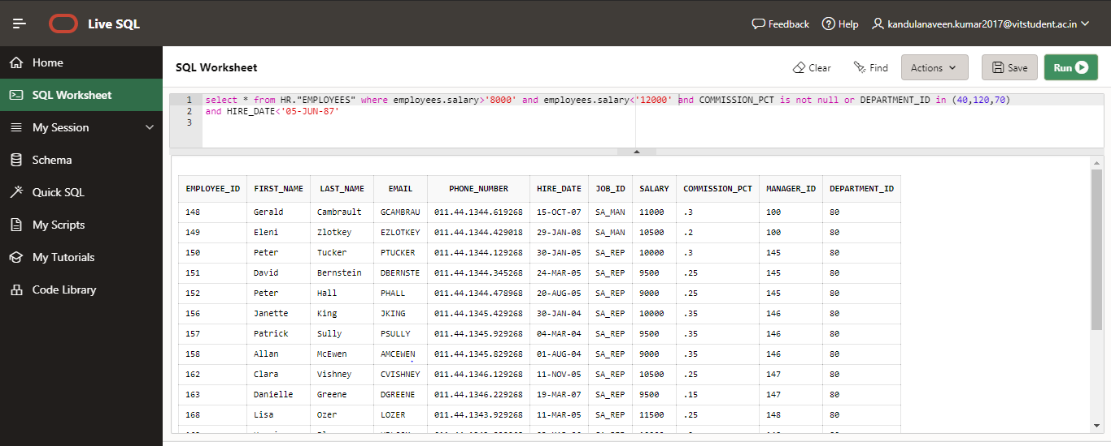

1. Write a query in SQL to display the full name (first and last), the phone number and email separated by hyphen, and salary, for those employees whose salary is within the range of 9000 and 17000. The column headings assign with Full_Name, Contact_Details and Remuneration respectively.

ANS:

select first_name||' '||last_name as fullname,phone_number||'-'|| email as contact,salary as remuneration

from hr.employees

where salary>'9000' and salary<'17000'

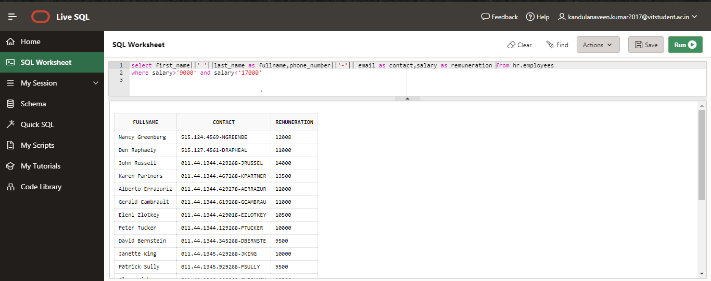

1. Write a query in SQL to display the full name (first and last) name, and salary, for all employees whose salary is out of the range 7000 and 15000 and make the result set in ascending order by the full name.

ANS:

select first_name||' '||last_name as fullname,salary from hr.employees where salary>'7000' and salary<'15000' order by first_name

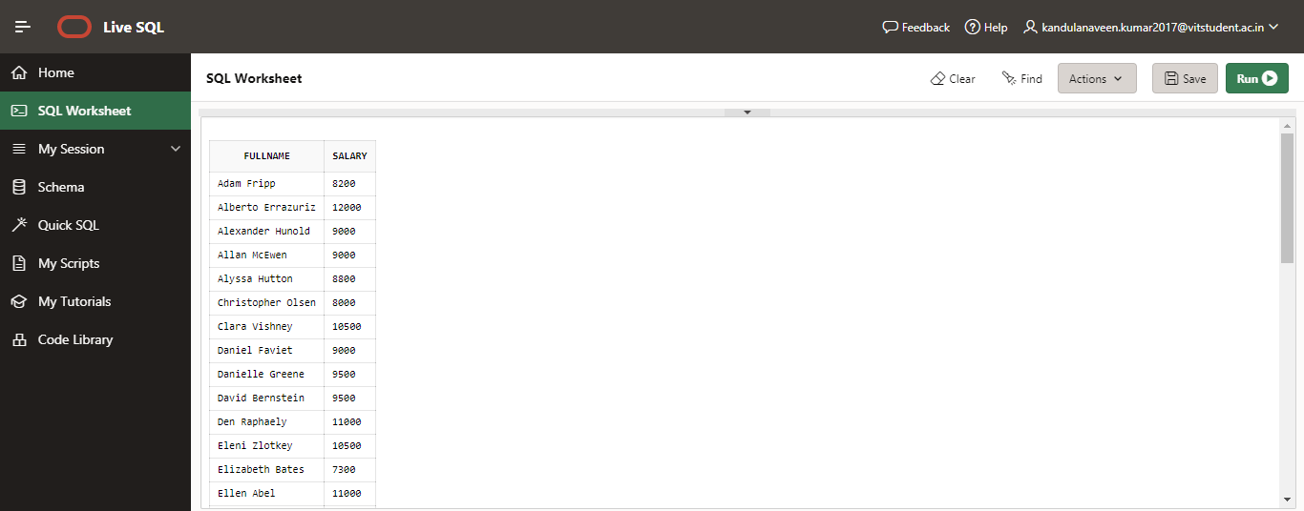

1. Write a query in SQL to display the first and last name, email, salary and manager ID, for those employees whose managers are hold the ID 120, 103 or 145

ANS:

select first_name,last_name,salary,email,manager_id from hr.employees where manager_id in (120,103,145)

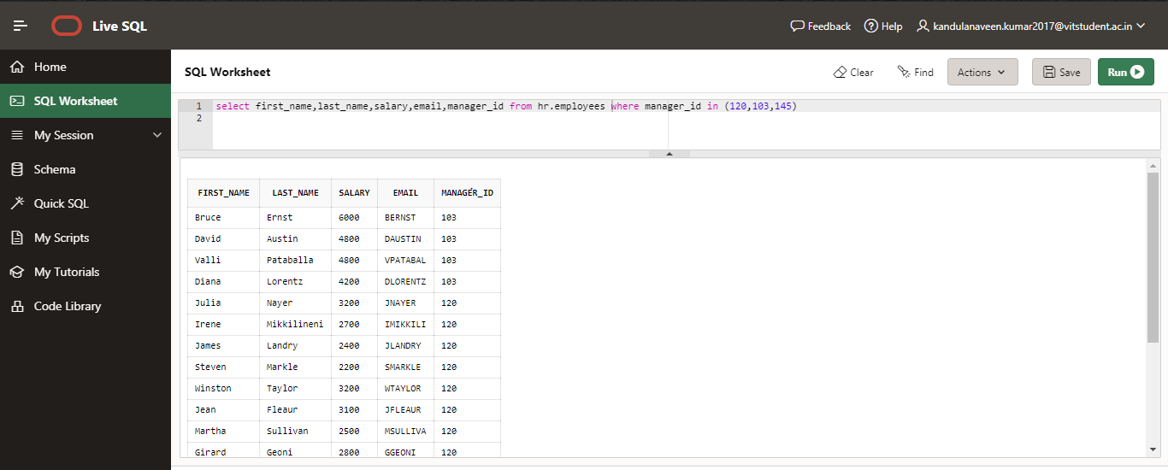

1. Write a query in SQL to display all the information from Employees table for those employees who was hired before June 21st, 2002.

ANS:

select * from hr.employees where HIRE_DATE<'21-Jun-02'

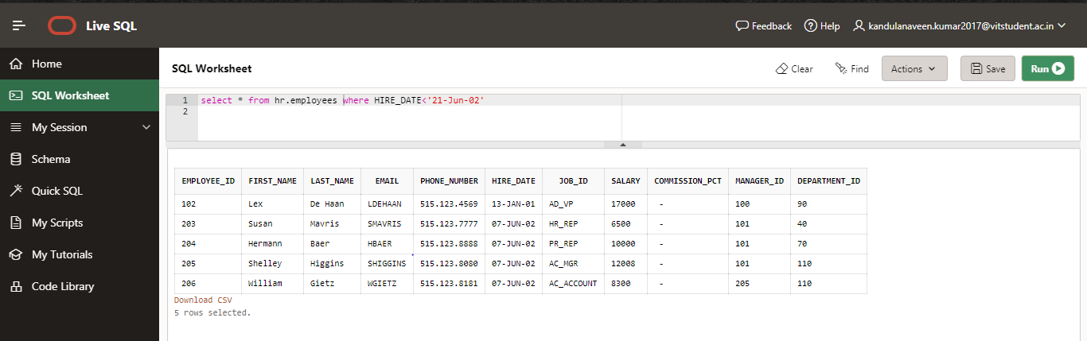

1. Write a query in SQL to display all the information for all employees who have the letters D, S, or N in their first name and also arrange the result in descending order by salary.

ANS:

select * from hr.employees where first_name like '%D%' or first_name like '%S%' or first_name like '%N%' order by salary DESC;

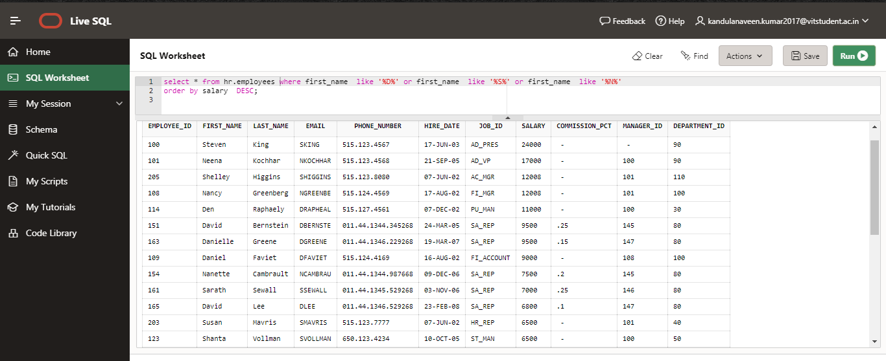

1. Write a query in SQL to display the full name (first name and last name), hire date, commission percentage, email and telephone separated by '-', and salary for those employees who earn the salary above 11000 or the seventh digit in their phone number equals 3 and make the result set in a descending order by the first name

ANS:

select first_name||' '||last_name as fullname,hire_date,COMMISSION_PCT,email||'-'|| PHONE_NUMBER as Contact,salary from hr.employees

where salary>'11000' or phone_number like '______3%' order by first_name desc;

